GEOMATH
Relational Systems Intelligence Across
Reduction, Isomorphism and Emergence
Research Thesis and University Collaboration Prospectus
Research Engagement Edition · Version 1.0 · August 2026
Joseph Murdoch
Independent GeoMath Research Program
REDUCTION ⇄ ISOMORPHISM ⇄ EMERGENCE
Particle ⇄ Relational Structure ⇄ Field

STATUS NOTE
This is a thesis-shaped research handover and collaboration document, not an examined university thesis. GeoMath is presented as an independent research framework, software architecture and set of testable hypotheses. Claims requiring scientific, mathematical, clinical or engineering validation are explicitly left open for formalisation, benchmarking and independent research.

Abstract
GeoMath is an independent research program investigating whether complex systems can be represented through a compact relational grammar in which identity, relation, change, observation, evidence, continuity and emergence are explicit parts of the computational model. Across a 66-file research compendium containing approximately 313,000 extracted words (about 60 distinct content items after duplicate-format pairs are collapsed), a recurring architecture has progressively converged: establish identity and context; represent relations and coupling; detect differential and transformation; compile a bounded FieldProfile; assess emergent structure; govern consequential transitions; preserve evidence and lineage; remeasure; and recursively establish the next baseline.
The central thesis developed in the most recent work is that reductionism and emergence can be treated as inverse directions through the same relational architecture. The reductionist direction asks what identities, relations and invariants remain when a system is decomposed. The emergent direction asks what higher-order structure or identity appears when those elements interact. Cross-domain isomorphism is proposed as the structural bridge: not visual similarity, but preservation of designated relational organisation through changes of scale, representation, topology, medium or domain. In compact form, the thesis can be expressed as Particle ⇄ Relational Structure ⇄ Field, or Identity ⇄ Structure ⇄ Higher-order Identity.
Field OS is the proposed computational realisation of this grammar through time. It is framed not as a replacement for conventional operating systems, but as a recursive relational runtime that maintains identity, context, coupling, evidence, governance and continuity across changing systems. Associated constructs include the FieldProfile as an intermediate relational state representation, Guardian as a separation between inference and authority, CoherenceToken as a transition and lineage record, and observer-coupled measurement under the working axiom that measurement is a coupling event.
This document consolidates the corpus into a coherent research thesis and proposes a university validation program. It deliberately avoids treating internal terminology as established mathematics or science. Instead, it identifies formalisation tasks, falsifiable hypotheses, comparison baselines, candidate experiments and research partnerships across complex systems, computer science, distributed systems, digital twins, spatial intelligence, human–AI interaction and responsible AI. The strongest immediate research question is whether explicit relational invariants provide useful, reproducible information across decomposition, emergence and cross-domain translation beyond what established object-state, graph, statistical or domain-specific methods already provide.
Source lineage: [S1] GeoMath Capture; [S4] Canonical Core; [S5] Primitive-Based Runtime White Paper; [S6] Thesis and Research; [S10] Major Insights Across the Body of Work.

Executive Research Brief
Central proposition: GeoMath models how relational identity and structure are preserved, transformed, reduced and re-emerge across scale, representation, domain and observation.

The body of work has reached a point where the primary challenge is no longer generating additional concepts. The stronger opportunity is to compress, formalise and test the architecture that has repeatedly reappeared across many experimental contexts. The current corpus already contains a disciplined validation posture: simulations demonstrate implementation behaviour, not physical truth; different evidence types remain distinct; apparent cross-domain correspondences must be tested rather than assumed; and negative results are treated as useful evidence.
For a university partner, the project is most useful when approached as a portfolio of bounded research questions rather than as a request to accept GeoMath as a completed theory. A collaboration could ask whether typed relational state representations improve system continuity, whether cross-domain invariant mappings survive controlled tests, whether observer-aware models improve provenance or human-in-the-loop performance, and whether higher-order relational states can be operationally promoted without losing lower-scale lineage.
Question | Current GeoMath position | University opportunity
What is the common object of study? | Identities embedded in changing relational fields. | Formalise the system model and compare with graph, dynamical-systems and state-space representations.
What joins reduction and emergence? | Preserved relational structure / candidate isomorphism. | Define exact preservation criteria and test exact, approximate and failed mappings.
What is Field OS? | A recursive architecture executing the relational grammar through time. | Implement reference kernels and benchmark against conventional orchestration / digital-twin architectures.
What makes the work falsifiable? | Mappings, invariants, predictions and continuity claims can fail. | Design preregistered tests with explicit comparison baselines and failure criteria.
What is the near-term outcome? | A narrowed canonical core and reproducible demonstrators. | Joint formalisation, benchmark suite, peer-reviewed papers and externally reproducible prototypes.

Contents
1. Research Status, Corpus and Method
2. Foundational Thesis: Relational Primacy
3. A Compressed GeoMath Kernel
4. Reductionism and Emergence as Dual Directions
5. Isomorphism as the Structural Bridge
6. Geometry, Triads, Symmetry and Invariance
7. Observer-Coupled Measurement and the FieldProfile
8. Field OS: Recursive Runtime, Governance and Lineage
9. Cross-Domain Instantiations
10. Provisional Formalisation Agenda
11. Research Hypotheses and Experimental Program
12. University Collaboration Opportunities
13. Validation, Limitations and IP-Safe Research Boundary
14. Conclusion
Appendix A — Canonical Working Vocabulary
Appendix B — Selected Internal Source Register
Appendix C — Proposed 12-Month Research Program
Appendix D — Original Research Sketch
Note: headings are intentionally structured for direct adaptation into a university research proposal, MPhil/PhD prospectus, industry research agreement or collaborative grant concept.

1. Research Status, Corpus and Method

1.1 Research status
GeoMath should presently be understood as an evolving research thesis, computational architecture and prototype program. The corpus itself repeatedly distinguishes concept, implementation, internal testing, external testing and domain validation. That distinction is retained here. The aim of this document is to make the research intelligible enough for an academic partner to challenge it, not to pre-empt that challenge by presenting unresolved hypotheses as established fact.
Several parts of the corpus originated in broader exploratory work on geometry, coherence, flow, learning, digital services, smart ecosystems and human–technology interaction. The current thesis keeps those historical strands only where they contribute to the relational architecture. Claims involving consciousness, physical fields, health, cognition or other high-evidence domains are not treated as established consequences of GeoMath. Where those topics remain relevant, they are framed as future experimental contexts requiring appropriate disciplinary methods.

1.2 Corpus reviewed
The supplied Compendium contains 66 files across DOCX, PDF, HTML, Markdown and legacy Word formats. Programmatic extraction produced approximately 313,000 words. Six document stems appear in both DOCX and PDF form, giving approximately 60 distinct content items. The corpus spans early digital-service and Society 5.0 work, Relational Learning, Field Dynamics and Adaptive Coherence Engine material, GeoMath laws and runtimes, the primitive architecture, Field OS, Relational Spatial Intelligence, Personal Field OS and the recent reductionism–emergence–isomorphism synthesis.
Term recurrence is not evidence of scientific validity, but it is useful for detecting conceptual persistence inside the corpus. Across the 66 extracted files, relation appears in 57 files, field in 56, coupling in 45, coherence in 45, observer in 41, geometry in 40, topology in 38, boundary in 37, baseline in 36, memory in 35, identity in 31, emergence in 30, Guardian in 28, transformation in 28, lineage in 26 and continuity in 24. The later terminology is therefore not entirely isolated from the earlier work; it increasingly formalises themes that recur across the archive.

1.3 Synthesis method
The thesis was assembled by treating the Compendium itself as a longitudinal design record. The method is qualitative and architectural rather than statistical. Recurring concepts were compared across domains, then compressed according to dependency: if one concept can be generated from another, it need not occupy the same ontological level. For example, the corpus repeatedly states that relation creates differential, suggesting that differential may be operationally indispensable while still being generated by identity-in-relation. Likewise, continuity is evaluated across transformation rather than existing independently of change.
The second method was cross-domain recurrence. Rather than assuming that repeated shapes or words imply universality, this synthesis asks whether the same role-structure appears in different contexts: identity, relation, boundary, transformation, observer, evidence, continuity and higher-order emergence. That approach directly motivates the later isomorphism hypothesis, while also creating the condition for falsification: if the relational mapping does not preserve useful structure or performance, the proposed isomorphism fails.
Source lineage: [S1], [S2], [S3], [S4], [S5], [S6], [S7], [S10]. Corpus counts are derived from the supplied Compendium extraction for this document.

2. Foundational Thesis: Relational Primacy

2.1 From isolated objects to relational systems
A persistent proposition across the research is that isolated objects do not carry enough information to explain many forms of system behaviour. A named entity becomes operationally meaningful when its boundary, context, relations, couplings, history and evidence can be established. GeoMath therefore treats relations not as decorative edges between already-complete objects, but as first-class structures that may carry direction, strength, timing, constraints, provenance, state and transformation history.
This does not require denying the usefulness of objects. GeoMath begins with distinguishable identity. The claim is instead that identity-in-relation often provides a more useful unit of systems intelligence than identity in isolation. Relational Learning illustrates the idea with simple examples: a book category becomes meaningful through comparison and arrangement; gardening knowledge emerges from interactions among plant, soil, water, sunlight and time; a child's perceived position changes relative to physical and social surroundings. The point is not that every concept is reducible to relation, but that relation creates differentials from which measurement and meaning can be derived.
Working law: A thing in isolation carries identity. A thing in relation creates differential. Differential permits measurement.

The Relational Primacy document develops the same intuition more formally. Relations generate local geometry; compatible and persistent relational closures can generate larger structure and form; the resulting geometry then constrains which future relations are possible. This creates a feedback loop rather than a one-way hierarchy. Local identities participate in relations, meso-level relational dynamics generate macro structure, and the macro structure changes the future possibilities of local identities.

2.2 Geometry as representation, not reality
The corpus also makes an important epistemic distinction: mathematics and geometry are modelling languages applied to relational conditions; they are not automatically identical to the underlying system. A triangle can represent a triadic relation, but the relation is not required to be literally triangular in physical space. A point can compress an identity, but that identity may unfold into a much richer internal field. This distinction becomes essential when GeoMath moves between spatial, computational, organisational and human-centred applications.

2.3 The research question that follows
If relational structure is treated explicitly, the central question becomes: can an intelligent system maintain a coherent, evidence-bounded model of identity, environment, relationships and observers as those relationships continuously change? This formulation is already present in the UQ outreach material and provides a strong university-facing entry point because it can be decomposed into conventional research questions in representation, inference, provenance, control, human–AI interaction and distributed computing.
Source lineage: [S2] GeoMath Laws; [S3] Relational Primacy, Systems Intelligence, Cognition and Memory; [S7] Relational Learning; [S18] UQ Outreach Draft.

3. A Compressed GeoMath Kernel

3.1 From sixteen primitives toward a smaller dependency structure
The Primitive-Based Runtime white paper defines a broad 16-primitive language covering structural, state, transformational, epistemic and generative concerns. That vocabulary remains useful for engineering. However, the later corpus increasingly asks whether all sixteen need to be ontologically fundamental. The recent compression proposes five operational elements: Identity, Relation, Difference, Transformation and Continuity.
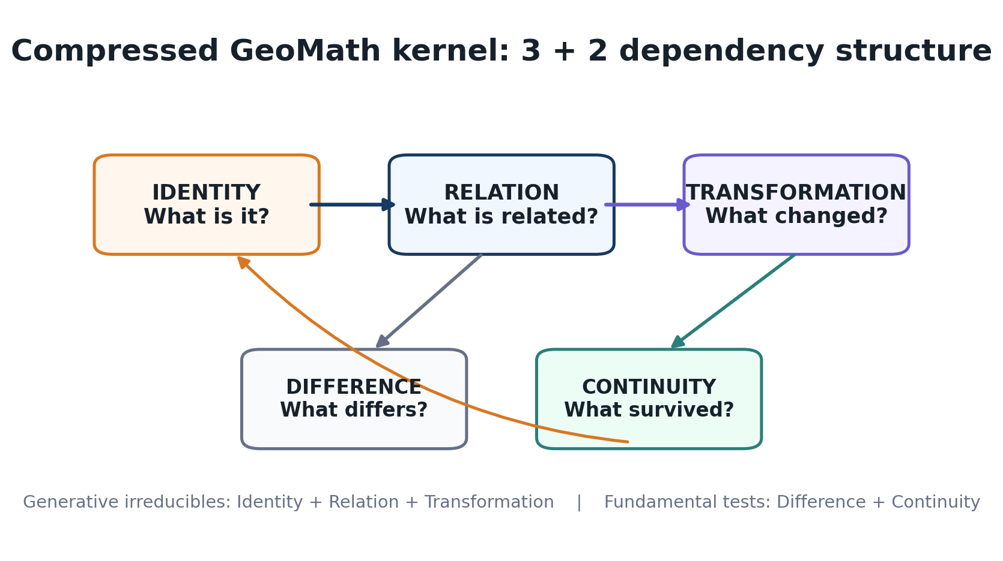
Figure 1. Proposed 3 + 2 compression of the GeoMath kernel. This is a synthesis-level model for research formalisation, not yet an externally validated ontology.

Element | Operational question | Dependency interpretation
Identity | What is it? | A distinguishable entity, object, node, relation or promoted field.
Relation | What is it related to? | Connects identities and permits comparison, coupling and contextual meaning.
Difference | What differs? | Operationally critical, but repeatedly generated by relation or comparison.
Transformation | What changed? | Maps one relational configuration into another through time or intervention.
Continuity | What survived? | Tests persistence, invariance, identity and lineage across transformation.

The deeper 3 + 2 interpretation is that Identity, Relation and Transformation are generative, while Difference and Continuity are fundamental tests. Identity enters relation; relation exposes difference; relations undergo transformation; continuity tests whether identity or structure remains recognisable after change. The cycle then repeats.

3.2 Derived structures
This compression does not discard the richer architecture. It instead treats many established GeoMath concepts as derived or assembled structures. A boundary is a relational distinction that defines valid scope. Coupling is an active relation participating in transformation. Differential is measured difference. An invariant is a condition expected to remain continuous. Topology is an arrangement of relations. Emergence is a transformation that yields a new identifiable whole. Observer/Measurement is an identity entering a measurement relation under specified conditions. Evidence captures the basis of a claim. Memory and lineage preserve ordered continuity across transformations. Scale and recursion allow relational structures to become identities at another level.

3.3 Why compression matters
The practical benefit of compression is conformance. A smaller kernel makes it easier to determine which parts of a build are fundamental, which are optional instruments and which are merely visualisations. It also reduces architecture inflation: a domain should not be forced to instantiate every GeoMath construct when a simpler relational model is sufficient. The Canonical Core already argues that BCE, digital twins and other instruments can remain lenses or modules unless the problem requires them.
Source lineage: [S1] GeoMath Capture; [S4] Canonical Core; [S5] Primitive-Based Runtime White Paper; [S15] GeoMath Runtimes; [S14] Runtime Ocean.

4. Reductionism and Emergence as Dual Directions

4.1 The recent synthesis
The most important conceptual development in the recent material is the recognition that GeoMath contains both a reductionist and an emergent direction. Reductionism asks what remains when a system is decomposed: distinguishable identities, constituent relations, boundaries and invariants. Emergence asks what new higher-order structure appears when those components interact. The two directions can be treated as inverse movements through one relational architecture rather than as competing philosophies.
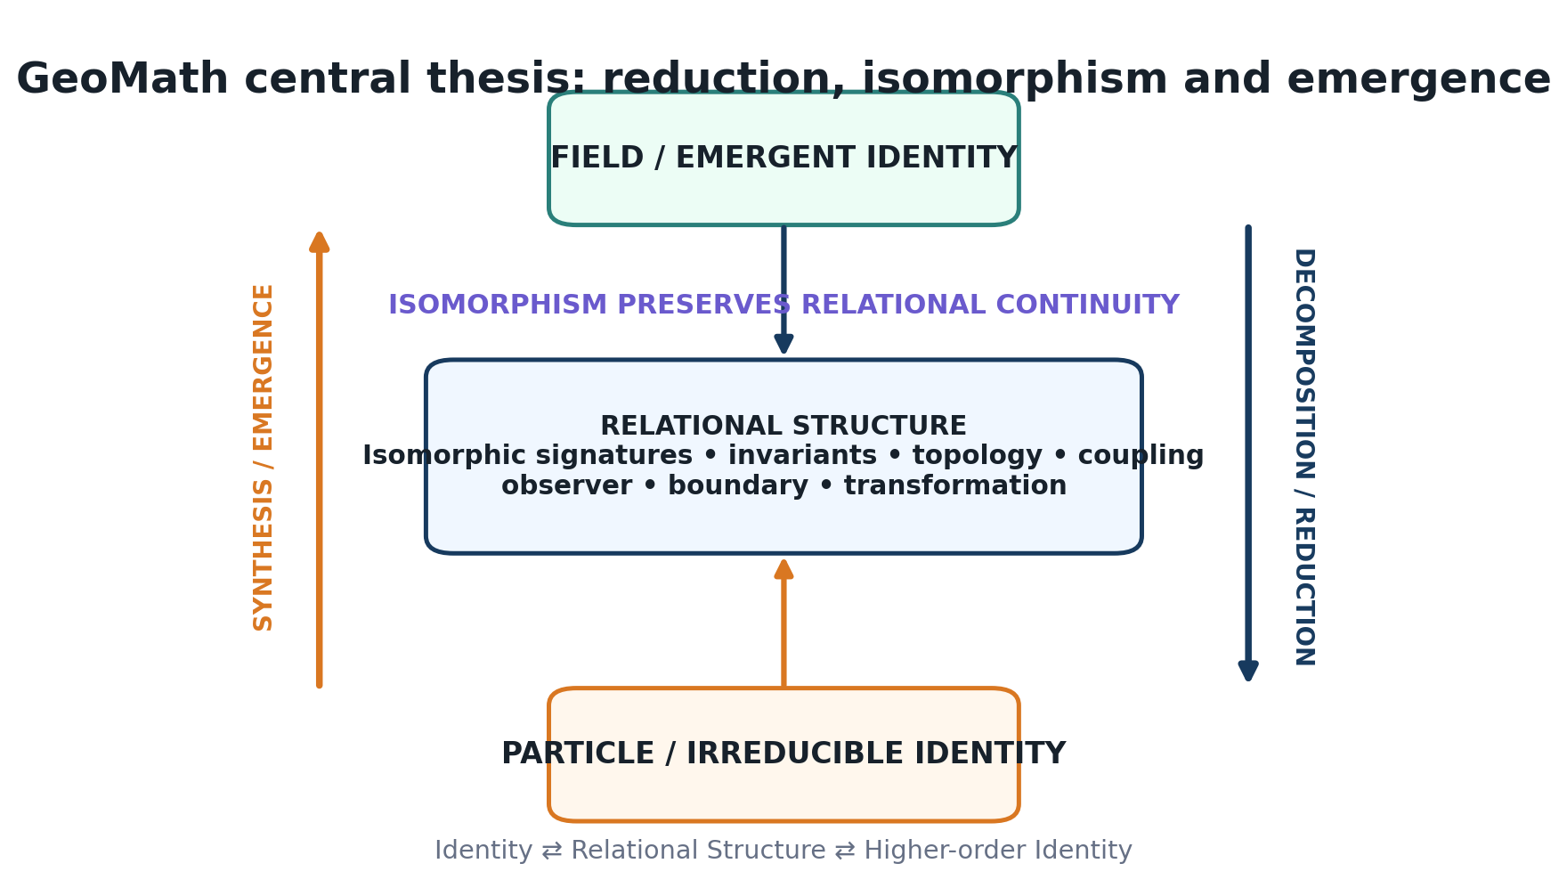
Figure 2. Central GeoMath thesis: particle / irreducible identity and field / emergent identity are linked through an intermediate relational structure in which invariants and isomorphic signatures can be tested.
The compact formulation is Particle / Object → Relation → Structure → Field → Emergence, with an inverse path from Emergent Field → Structure → Relations → Constituent Identities. In this model, reduction is not understood as eliminating the whole, and emergence is not understood as abandoning the parts. Both depend on retaining enough relational lineage to move between levels.

4.2 Relational centre and relational core
The recent vocabulary of Relational Centre and Relational Core gives this duality a geometric expression. The centre is a point-like compression: a localised coordinate, node, object or decision point. The core is an extended field representation with internal topology, gradients, density, deformation and relational structure. The working maxim in the recent capture is: ‘A point is a compressed field. A field is an unfolded point.’ The phrase should be understood as a modelling principle rather than a claim about physical ontology.
A centre can move while a core remains relatively stable; a core can deform while its centre remains fixed; both can change during relational reorganisation; a core can fragment into multiple local centres; multiple centres can reintegrate. These distinctions create a useful language for separating translation, deformation, fragmentation and integration without automatically treating each change as loss of identity.

4.3 Emergence as higher-order identity
The recursion becomes particularly clear when emergence is defined as relational transformation producing a new identifiable whole. Local entities can form a network; a persistent and bounded network may be promoted to a higher-order identity; that identity can then enter another relational field. Importantly, promotion is not automatic. The Canonical Core names persistence, coherence, boundary integrity, distinguishability, evidence and lineage as candidate conditions for higher-order promotion.
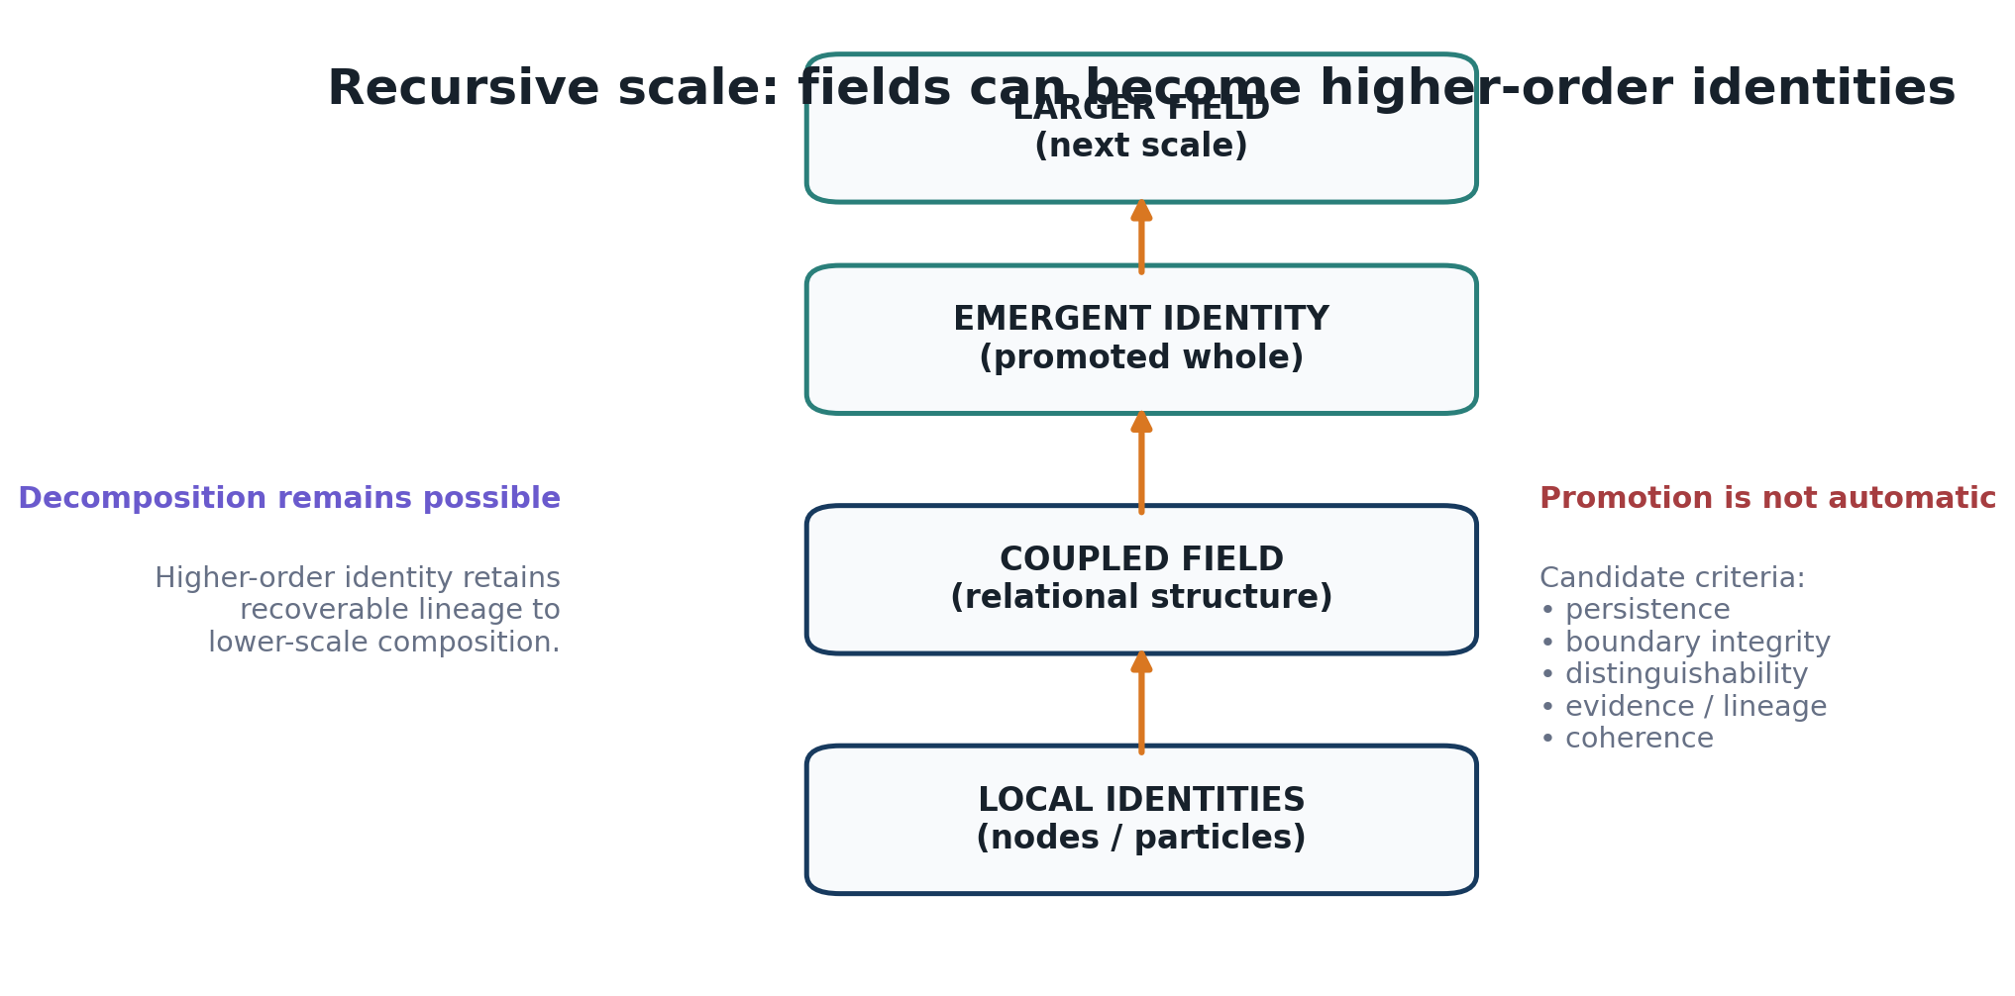
Figure 3. Recursive scale model: a relational field may become a higher-order identity while retaining recoverable lineage to its constituent structure.
Source lineage: [S1] GeoMath Capture; [S3] Relational Primacy; [S4] Canonical Core; [S7] Relational Learning.

5. Isomorphism as the Structural Bridge

5.1 From visual similarity to preserved relational organisation
Isomorphism is the conceptual bridge that allows the reductionist and emergent sides of GeoMath to remain part of one modelling language. The corpus repeatedly warns that isomorphism should not mean ‘these diagrams look similar.’ The stronger working hypothesis is that a relational organisation or runtime pattern may preserve its identity while changing form, scale, medium, representation or domain.
The GeoMath Laws describe this as a preserved signature: shape, scale, domain, node count, medium, language or visual expression may change while the underlying relational logic remains recoverable. Thesis and Research describes isomorphism as a live transition logic for preserving relational identity across transformation. The recent synthesis extends this into the reduction–emergence bridge: reduction identifies constituent structure and invariants; isomorphism tests what survives translation; emergence identifies the higher-order field produced by the relations.
Reduction → invariant / isomorphic structure → emergence

5.2 Cross-domain isomorphism
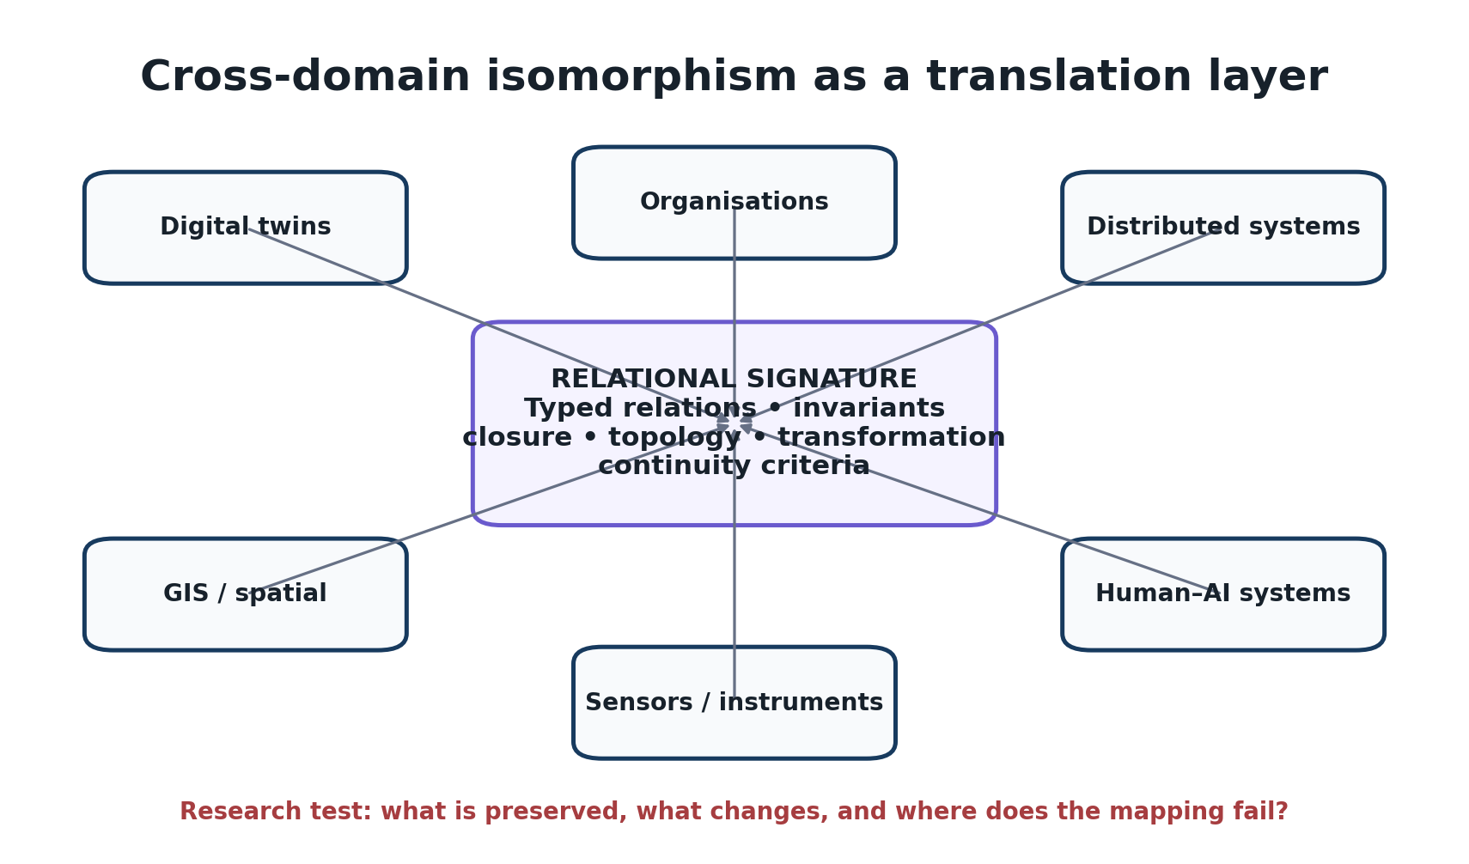
Figure 4. Cross-domain isomorphism as a translation layer. The scientific task is to test what is preserved, what changes and where a proposed mapping fails.
Cross-domain work has been a persistent feature of the Compendium: digital services, learning, organisations, smart ecosystems, GIS, distributed systems, digital twins, sensors, AI and personal technology have all been explored through recurring questions of identity, relation, boundary, coupling, change and continuity. The isomorphism hypothesis provides a coherent explanation for that breadth: the research has been searching for relational structures that may survive translation between domains.
For university research, however, this is precisely where discipline is needed. A useful cross-domain correspondence must do more than produce an attractive analogy. It should preserve formally specified relations or invariants and ideally improve prediction, diagnosis, compression, transfer or explanation. A failed mapping is informative because it identifies the boundary of the proposed relational grammar.

5.3 Three forms of invariance
Form | Question | Example research criterion
Identity invariance | Is this still the same entity? | Designated identity constraints survive allowed state or carrier changes.
Symmetry invariance | What survives an internal transformation? | Selected properties remain unchanged under permitted re-orderings or geometric transformations.
Isomorphic invariance | What relational organisation survives translation? | A mapping preserves specified typed relations / invariants between two representations or domains.

These distinctions matter because ‘sameness’ is otherwise overloaded. A system can change state while preserving identity; a structure can transform internally while preserving symmetry properties; and two domain models can preserve a relational pattern without sharing surface form. GeoMath needs explicit criteria for each case.

5.4 Terminology caution for academic formalisation
In mathematics, isomorphism has exact meanings that depend on the structures being mapped. GeoMath currently uses the term more broadly as a working label for preserved relational organisation. A university collaboration should therefore formalise the term and determine when the correct relation is exact isomorphism, graph isomorphism, homomorphism, equivalence, approximate structural matching, simulation relation or another established concept. The same caution applies to the word field: in GeoMath it often denotes an extended relational state or interaction context and should not be confused automatically with a physical field in physics.
Source lineage: [S2] GeoMath Laws; [S6] Thesis and Research; [S1] GeoMath Capture; [S8] Relational Spatial Intelligence.

6. Geometry, Triads, Symmetry and Invariance

6.1 Geometry as discovery and representation
Geometry is unusually persistent across the corpus. Point, line, circle, triangle, boundary, lattice, manifold, topology, centre, sphere and field repeatedly serve as ways to reason about relational organisation. The research does not require every domain to be literally geometric. Rather, geometry acts as a compact language for distinction, adjacency, orientation, closure, scale and transformation.

6.2 Monad, dyad and triad
The GeoMath Laws organise early relational development as monad → dyad → triad → higher-order structure. The monad provides distinguishable local identity. The dyad introduces relation, polarity and measurable difference. The triad is proposed as the first stable relational closure: three distinguishable positions with recoverable structure, inside/outside distinction and the possibility of triangulation. Higher-order structures then expand relational bandwidth, pathways and emergence potential.
The Relational Primacy document adds an important clarification: the triad is relational, while the triangle is one geometric carrier or projection. A three-role relational lock could therefore remain active even when the visible topology is not triangular. This distinction should be preserved in future formal work.

6.3 BCE as a runtime triad
Baseline–Coupling–Emergence (BCE) is one of the most persistent operational triads in the corpus. Baseline establishes a reference condition; Coupling activates interaction; Emergence identifies a higher-order condition produced by those interactions. Remeasurement then evaluates difference and continuity, allowing a justified rebaseline. Under the compressed kernel, BCE is best treated as a useful runtime expression of deeper relational processes rather than as the final ontology.

6.4 BCE symmetry state space
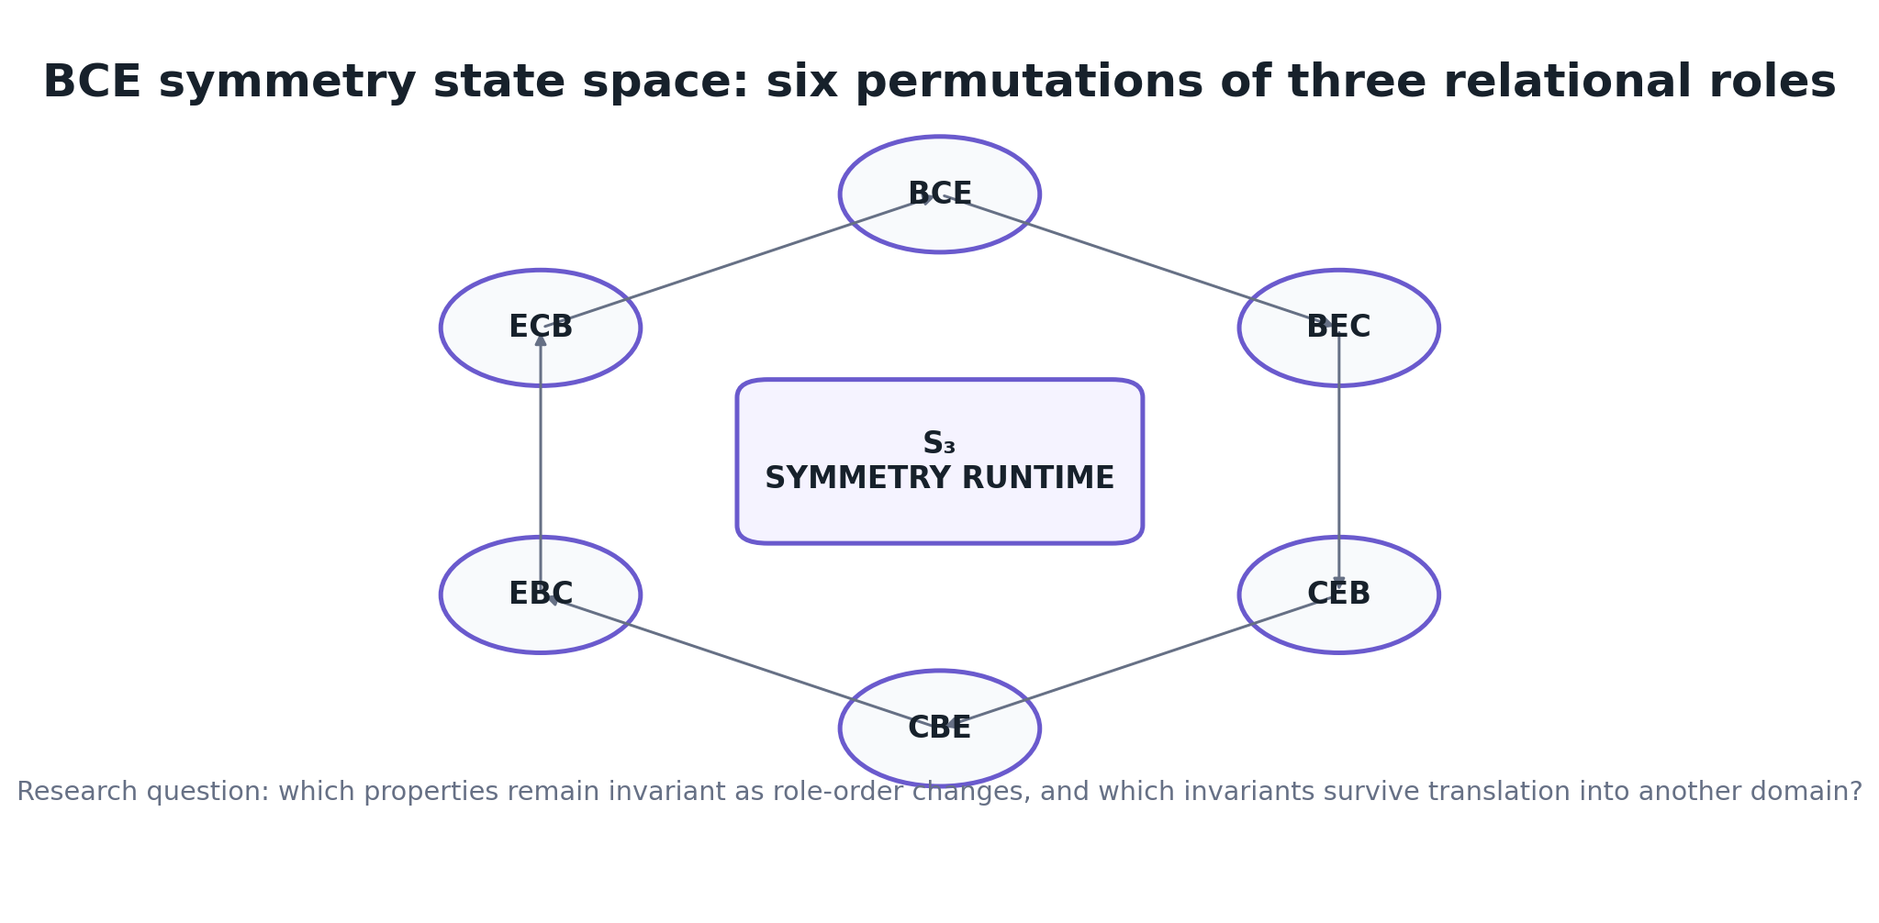
Figure 5. The six permutations of Baseline, Coupling and Emergence form the S₃ permutation group. GeoMath can use this as a research instrument for studying role-order transformations and invariant properties.
The recent sketch work notes that BCE, BEC, CEB, CBE, EBC and ECB are the six permutations of three elements and therefore form the symmetric group S₃. This does not by itself validate any physical or computational claim, but it provides a legitimate mathematical anchor for studying how a three-role runtime changes under permutation. A symmetry runtime can ask what remains invariant when role order changes; an isomorphic runtime can ask whether a corresponding relational organisation survives translation into another system or domain.
Source lineage: [S2] GeoMath Laws; [S3] Relational Primacy; [S1] GeoMath Capture.

7. Observer-Coupled Measurement and the FieldProfile

7.1 Measurement as coupling
A major maturation in the recent architecture is the explicit separation between the world, observation and representation. The Canonical Core adopts the working axiom ‘Measurement is a coupling event.’ A measurement has a source or observer, method, time, context, purpose, evidence state and relation to the system being measured. It therefore produces a bounded claim about system state rather than privileged access to reality.
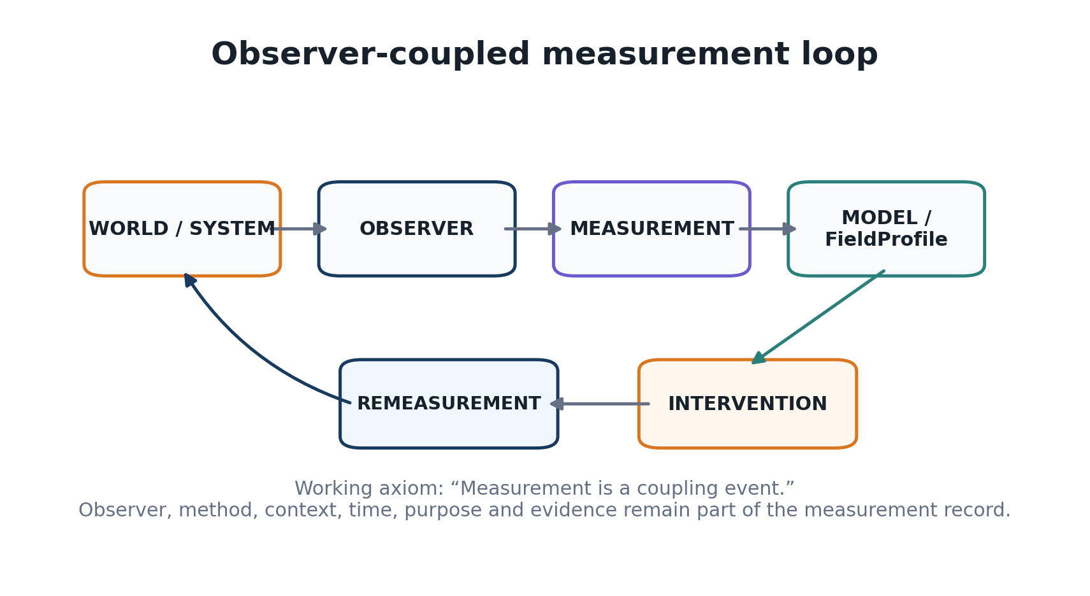
Figure 6. Observer-coupled measurement loop. Measurement conditions remain part of the state and provenance record rather than being discarded after observation.
This is especially relevant to systems combining sensors, user reports, AI inference and external records. The corpus argues that direct observation, derived metric, report, inference, prediction, stale data, contradiction and unknown state should remain distinguishable. The objective is not to deny inference, but to prevent weak evidence from silently acquiring the authority of stronger evidence.

7.2 FieldProfile as an intermediate representation
GeoMath does not jump directly from heterogeneous observations to whole-system conclusions. It compiles a FieldProfile: a bounded, contextual representation of the current relational condition. Depending on the application, a FieldProfile may include identity, context, baseline, active relations, coupling, differential, current state, drift, observer conditions, evidence, provenance, memory, topology, uncertainty and Guardian interpretation.
The critical statement is that the FieldProfile is not the underlying reality. It is a governed computational interpretation of selected state. This makes it a candidate common intermediate representation across domains while preserving the right to use different domain-native models underneath. A hospital, sensor network, GIS system or personal technology stack need not share one ontology; they can expose enough structured relational state for higher-level comparison and governance.

7.3 Actual, claimed and perceived states
The corpus also distinguishes Actual, Claimed and Perceived state. ‘Actual’ is not asserted as metaphysical truth; it refers to the strongest available evidence-bounded operational reading. Claimed state is what an actor or system declares. Perceived state is how that condition is interpreted or experienced. These states may converge or diverge, and GeoMath proposes preserving the disagreement rather than averaging it away.
Source lineage: [S4] Canonical Core; [S5] Primitive-Based Runtime White Paper; [S9] Personal Field OS; [S18] UQ Outreach Draft.

8. Field OS: Recursive Runtime, Governance and Lineage

8.1 GeoMath versus Field OS
The Canonical Core makes a useful architectural separation: GeoMath is the relational systems-intelligence grammar; Field OS is the recursive operating architecture that executes that grammar through time. Field OS is not presented as a replacement for Windows, Linux or device operating systems. Its proposed role is to maintain relational state and continuity across nodes, networks and higher-order system scales.
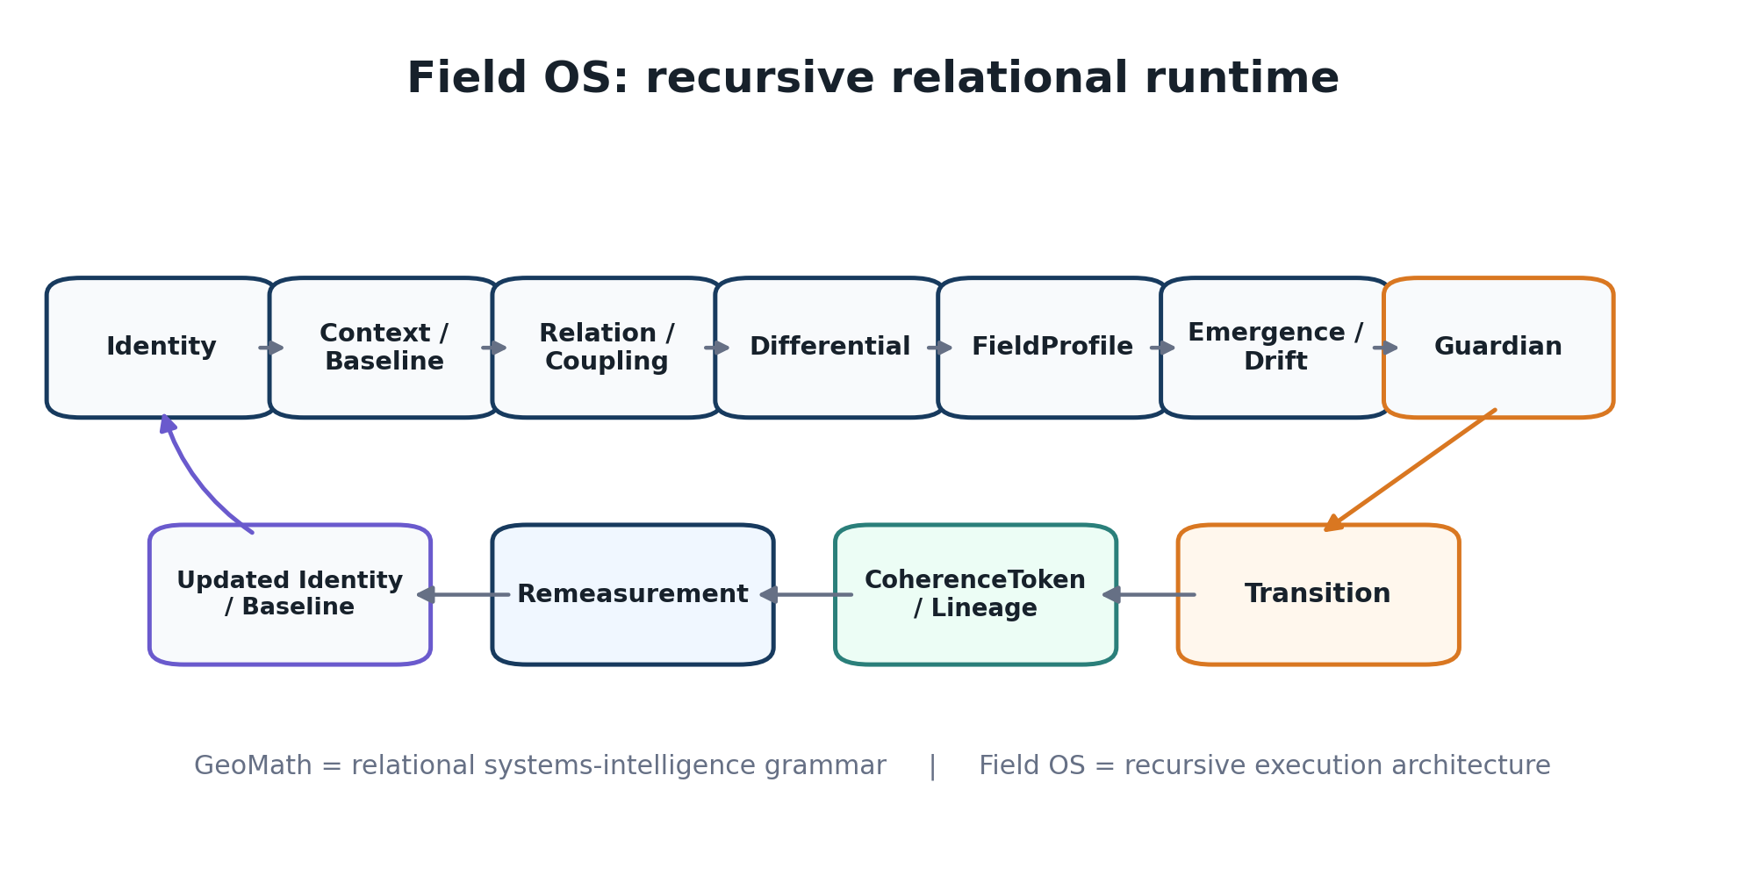
Figure 7. Canonical Field OS loop: establish identity and baseline, evaluate relations and differential, compile FieldProfile, assess emergence, govern transition, preserve lineage, remeasure and repeat.
The recurring runtime can be expressed as Identity → Context / Baseline → Relation + Coupling → Differential → FieldProfile → Emergence / Drift → Guardian → Transition → CoherenceToken / Lineage → Remeasurement → Updated Identity / Baseline → repeat. This loop provides a stronger unifying explanation of the many specialised runtimes in the archive: they can be understood as domain modules, instruments or lenses attached to a smaller recurrent kernel.

8.2 Guardian: inference is not authority
Guardian is the governance membrane over consequential transitions. The architecture explicitly separates knowing or predicting a state from permission to act on it. Guardian can evaluate baseline validity, evidence sufficiency, system boundary, identity preservation, invariants, uncertainty, reversibility, recovery and actor authority. Canonical routes include OPEN / PROCEED, HOLD, REMEASURE, BRIDGE, RECOVER and VETO.
This separation creates a clear research bridge into responsible AI and autonomous systems: a model may produce an inference, while a distinct governance layer determines whether a transition is admissible under the available evidence and authority. The thesis does not claim that the current Guardian implementation is superior to established safety, access-control or policy systems; that is an empirical question for comparison.

8.3 CoherenceToken and active memory
CoherenceToken is being developed as a continuity, evidence and lineage record associated with a governed transition. It can preserve what was being modelled, which evidence was available, what FieldProfile was constructed, which observer frame applied, what transition was proposed, which Guardian route was selected and what happened afterward. The purpose is replayability and inspectability rather than merely attaching a ‘coherence’ score.
Memory is consequently active rather than archival. Two systems with the same apparent present state can have different trajectories, residues, dependencies and allowable next actions. History can therefore be part of current state. This principle underlies persistent identity, recovery, device replacement, distributed continuity and personal save-state concepts.
Source lineage: [S4] Canonical Core; [S5] Primitive-Based Runtime White Paper; [S9] Personal Field OS; [S14] Runtime Ocean.

9. Cross-Domain Instantiations
The Compendium is unusually broad, but the breadth becomes more coherent when each domain is treated as an instantiation or test of the relational grammar rather than as a separate theory. The sections below identify the strongest research embodiments without implying that any one domain has already validated the whole framework.

9.1 Relational Spatial Intelligence
The GIS / spatial work is one of the clearest bridges to established technical practice. Points can represent identities; lines can represent couplings, dependencies or flows; polygons can represent bounded fields, jurisdictions or operational conditions; layers can be treated as interacting system components. The conceptual progression moves from ‘Where is it?’ to ‘What is it connected to?’, ‘What changed between those relationships?’, ‘What condition is emerging?’, ‘What governance route follows?’ and ‘What evidence should be preserved?’
The opportunity is not to replace GIS, but to test whether a relational runtime above spatial representations improves diagnostics for changing dependencies, multimodal layers, cascading failure, infrastructure risk or decision provenance.

9.2 Relational digital twins
A conventional digital twin may model selected physical or operational properties of an entity. A GeoMath relational twin additionally emphasises identity, relations, topology, baseline, differential, evidence, observer conditions, authority, lineage and permitted transitions. The twin remains a computational representation rather than the person or physical system itself. Multiple twins can therefore be coupled while preserving separate identity, state ownership and authority boundaries.

9.3 Distributed systems and continuity
The distributed-system line treats logical identity as potentially distinct from its current carrier. This leads to testable questions about whether a system can preserve meaningful state, lineage and governance while hosts fail, devices are replaced or topology changes. The Personal Field OS work gives a user-centred version of the same problem: one persistent relational core, many devices and environments, continuous identity.

9.4 Human–AI–environment systems
The Personal Field OS work reframes phone, computer, wearables, environmental sensors, AI and digital twins as a user-centred relational field rather than isolated applications. The strongest engineering version is continuity-centred computing: the user remains persistent while devices become temporary embodiments. The research value is in multimodal provenance, context handoff, adaptive interfaces, state re-entry, privacy and permissioned coupling—not in assuming that subjective or cognitive states are directly measurable.

9.5 Organisations, infrastructure and AI governance
Organisations and infrastructure can be modelled through changing dependencies rather than static inventories alone. AI systems can be examined through evidence, provenance, observer conditions and separation of inference from action. These domains are useful because they create measurable consequences and established comparison methods. They also provide a test of whether the relational grammar is genuinely transferable or merely redescribes existing practices under new terminology.

10. Provisional Formalisation Agenda
The source corpus contains emerging equations and runtime notation, but it does not yet provide a single externally reviewed mathematical specification of GeoMath. For university work, formalisation should precede broad claims. The following model is therefore proposed as a research scaffold derived from the corpus, not as a canonical theorem.

10.1 Candidate relational system model
Provisional research notation: Rₜ = (V, Eₜ, Bₜ, Xₜ, Oₜ, Pₜ, Lₜ)

Here V denotes distinguishable identities; Eₜ denotes typed relations or couplings at time t; Bₜ denotes boundaries and contextual constraints; Xₜ denotes state variables and differentials; Oₜ denotes observer / measurement conditions; Pₜ denotes evidence and provenance; and Lₜ denotes memory / lineage. A transformation T maps Rₜ to Rₜ₊₁. This notation is intentionally generic so that domain-native mathematics can remain inside each component rather than being replaced by a single universal metric.

10.2 Candidate invariant set
Let K be a set of designated properties expected to remain stable under a class of allowed transformations. K might contain identity constraints, typed adjacency, closure, boundary relations, ordering, conservation conditions, permitted transition rules or lineage requirements. Continuity is then not ‘nothing changed’; it is the claim that specified properties in K remain satisfied or recoverable across T.

10.3 Candidate cross-domain mapping
For systems A and B, a candidate mapping φ: Rᴬ → Rᴮ should be evaluated against explicitly declared preservation criteria. An exact isomorphism would require preservation appropriate to the formal structure being used. In many practical systems the relevant concept may instead be partial, approximate or role-preserving correspondence. GeoMath should therefore record both the preserved signature and the non-isomorphic residue: the structures that fail to map, distort or generate novelty.

10.4 Candidate emergence criterion
A substructure H may be considered for promotion into a higher-order identity only when explicit criteria are met. Candidate criteria already present in the corpus include persistence, coherence, boundary integrity, distinguishability, evidence and lineage. University research should determine whether these can be defined in a domain-independent way or must remain domain-specific. The latter result would still be valuable because it would establish the limits of the common grammar.

10.5 Formal comparison agenda
Established research area | GeoMath comparison question
Graph / network models | Does typed relational state add information beyond conventional nodes, edges, attributes and temporal graphs?
Dynamical systems / state space | Can GeoMath baseline, differential and emergence be mapped cleanly onto established state-transition formalisms?
Systems engineering / digital twins | Does the FieldProfile + lineage architecture improve traceability, continuity or governance?
Control / decision systems | How does Guardian compare with constraints, supervisory control, policy engines or assurance layers?
Provenance / event sourcing | Does CoherenceToken provide distinct value beyond established audit, provenance and event-log models?
Category / structural mathematics | Which GeoMath “isomorphisms” are exact structural isomorphisms and which are weaker mappings?
Human–computer interaction | Does observer-aware, continuity-centred modelling improve adaptive interfaces without increasing cognitive burden?

Source lineage: This chapter is a synthesis-level formalisation proposal derived from [S1], [S2], [S4], [S5] and [S6]. It is deliberately marked provisional.

11. Research Hypotheses and Experimental Program
The most useful handover to a university is a set of hypotheses that can fail. The following program converts the current architecture into experiments with comparison baselines and explicit negative outcomes.
ID | Hypothesis | Initial test | What would count against it?
H1 | Explicit relational representation provides useful information beyond isolated object-state descriptions. | Compare GeoMath-style typed relational state with a conventional object-state or temporal graph baseline on the same task. | No improvement in prediction, diagnosis, compression, interpretability or traceability; added complexity without benefit.
H2 | Selected relational invariants can survive transformation of scale or representation. | Apply controlled transformations and test whether declared invariant sets remain recoverable. | Invariant recovery is unstable, arbitrary or no better than simpler descriptors.
H3 | Useful structural correspondences can transfer across at least some distinct domains. | Train / specify a relational signature in Domain A and test constrained transfer to Domain B. | Performance collapses; preserved features are superficial; domain-specific baseline performs better.
H4 | Observer and provenance modelling improves epistemic integrity in multimodal systems. | Compare systems that preserve source/method/context/evidence labels with systems that flatten observations. | No improvement in conflict detection, calibration, auditability or decision quality.
H5 | Runtime separation of inference and authority improves governance of consequential transitions. | Compare Guardian-style gating against a system in which model outputs directly drive actions. | No measurable safety, auditability or recovery benefit; unacceptable latency or complexity.
H6 | Logical identity can remain continuous across carrier or topology changes when lineage and invariants are explicit. | Distributed failover / device replacement experiment with controlled state migration. | Identity cannot be reliably distinguished from copied state; lineage breaks or recovery is inferior to established methods.
H7 | A higher-order relational field can be promoted to a useful identity without losing lower-scale lineage. | Multi-scale simulation with defined promotion criteria and downstream tasks. | Promoted state adds no information, obscures local failures or becomes unstable under perturbation.

11.1 Experiment A — Cross-domain invariant transfer benchmark
Select two domains with clear data and limited ethical risk—for example a computer dependency network and a simulated infrastructure network. Define the candidate relational signature before looking at transfer performance. Measure which structural properties survive translation, which do not, and whether the transferred representation improves any downstream task. This experiment directly tests the central isomorphism claim while allowing a clean null result.

11.2 Experiment B — Relational state versus conventional baseline
Build matched representations of the same dynamic system: one conventional object / attribute or temporal graph model and one GeoMath-style FieldProfile with explicit baseline, coupling, evidence and lineage. Use identical downstream tasks. Evaluate predictive performance, anomaly detection, explanation quality, auditability, computational cost and robustness to missing or contradictory data.

11.3 Experiment C — Observer-aware multimodal measurement
Create a controlled multimodal task in which sensors, user reports and model inferences occasionally conflict. Compare an evidence-flattened system with an observer-aware system that preserves source, method, time, context and epistemic type. The primary outcome should be whether disagreements and uncertainty are represented more faithfully, not whether the system produces a higher arbitrary ‘coherence’ score.

11.4 Experiment D — Distributed identity continuity
Use a small cluster or simulated device mesh. Establish a logical identity, baseline and lineage record, then deliberately remove hosts, change topology or replace devices. Test whether the system can preserve authorised state and prove continuity while also distinguishing legitimate continuation from an unauthorised copy or stale replay. Compare against established replication, event sourcing and identity mechanisms.

11.5 Experiment E — Recursive emergence and promotion
Use a multi-agent or network simulation in which local nodes form persistent relational structures. Define promotion criteria in advance. Test whether a promoted higher-order identity improves prediction or control at the next scale while retaining traceable decomposition to local state. Evaluate false promotion, delayed promotion and cases where local incoherence is hidden by a global aggregate.

11.6 Experiment F — Personal Field OS creative re-entry pilot
The Personal Field OS document proposes creative work as a pragmatic first human-centred study. Participants could perform writing, design or coding tasks, save a user-designated high-value interval, leave for a controlled break and return with either conventional project restoration or a structured state-re-entry interface. Outcome measures could include time to task resumption, self-reported continuity, interruption cost, error rate and cognitive burden. Any biometric or behavioural signals should be treated as limited observations, not direct measures of thought or consciousness.
Source lineage: [S4] Canonical Core research questions; [S5] Primitive-Based Runtime White Paper validation section; [S6] Thesis and Research; [S9] Personal Field OS; [S18] UQ Outreach Draft.

12. University Collaboration Opportunities

12.1 Why the project is ready for academic engagement
The project now has three ingredients that make university involvement timely: a substantial source corpus, a converging canonical architecture and a growing suite of prototype directions. The missing ingredient is independent disciplinary pressure. The work needs researchers who can translate internal terms into established literature, identify prior art, reject unnecessary primitives, formalise the strongest claims and design tests that can genuinely fail.

12.2 Suitable research homes
Discipline / group | Potential contribution | Candidate project
Computer science / distributed systems | Formal identity, state replication, provenance, failover, topology change. | Distributed identity continuity and Field OS reference kernel.
Complex systems / network science | Multi-scale relational structure, emergence, invariants, phase transitions. | Recursive promotion and cross-scale invariant benchmark.
Applied mathematics | Formalise transformations, symmetry, exact vs approximate isomorphism. | Mathematical specification of the GeoMath relational signature.
AI / responsible AI | Observer provenance, uncertainty, inference–authority separation. | Guardian-style decision gating and evidence-aware agent architectures.
HCI / human-centred AI | Observer coupling, personal continuity, adaptive interfaces, cognitive load. | Creative re-entry / Personal Field OS pilot.
GIS / spatial intelligence | Dynamic spatial relations, multimodal layers, topology and provenance. | Relational Spatial Intelligence benchmark.
Digital twins / systems engineering | State ownership, relational twins, lineage, governed transitions. | Coupled twin architecture with explicit evidence and authority boundaries.
Design research / visual analytics | Geometry as modelling language and multi-representation interfaces. | Comparative study of point, graph, field and spatial representations of the same canonical state.

12.3 Recommended engagement sequence
- Initial research conversation: test whether the core questions are academically meaningful before discussing the complete architecture.
- IP-safe demonstration: show selected prototypes and conceptual figures without disclosing source code, proprietary mappings, thresholds or unpublished algorithms.
- Formalisation workshop: translate GeoMath terms into established disciplinary concepts and identify overlap, novelty and redundancy.
- Joint experiment selection: choose one narrow hypothesis with available data, a credible baseline and an unambiguous failure condition.
- Independent replication: package data, code and protocol so a separate group can reproduce or challenge the result.
- Publication and next-stage program: only scale the research claims that survive comparison and independent review.

12.4 What the university is being asked to do
Not: “accept GeoMath as true.” Rather: “help formalise, challenge, benchmark and independently test the strongest parts of the architecture.”

This distinction is central to the tone of engagement. The breadth of the Compendium is a source of hypotheses, not a substitute for evidence. A productive partnership would be expected to simplify the framework, identify where conventional terminology is sufficient, and document negative results as carefully as positive ones.
Source lineage: [S10] Major Insights; [S18] UQ Outreach Draft; [S4] Canonical Core; [S9] Personal Field OS.

13. Validation, Limitations and IP-Safe Research Boundary

13.1 Current validation posture
A recurring strength in the current Canonical Core is the separation of evidence states. Concept means a proposed architecture or mechanism. Implemented means a functioning prototype exists. Tested means repeatable internal tests exercise mechanisms and failure modes. Externally tested means an independent group can reproduce or challenge the results. Validated for domain use requires domain-specific evidence, safety and regulatory requirements. This thesis adopts the same ladder.
A simulation can demonstrate that a runtime executes coherently; it cannot by itself validate a physical, clinical, psychological or scientific claim. Similarly, the recurrence of a relational pattern across the Compendium is evidence of internal conceptual convergence, not proof that nature or all complex systems share that structure.

13.2 Main limitations
- The internal terminology is richer than the current external formalisation. Several terms may overlap established mathematics, computer science, systems engineering or design research and must be mapped carefully.
- The word “isomorphism” is currently broader than its strict mathematical usage and requires exact definitions for each research task.
- “Field” is often a relational systems representation, not a claim of a physical field; future publications must keep that distinction explicit.
- Many prototypes are demonstrators rather than benchmarked implementations. Performance comparisons against established methods remain to be done.
- Cross-domain breadth creates a risk of analogy inflation. Each mapping needs predeclared invariants and failure criteria.
- Human-centred and cognitive applications require stronger ethical, privacy and measurement boundaries than purely synthetic systems.
- No claim of novelty or patentability is made in this document. Prior-art and literature review remain separate professional and academic tasks.

13.3 IP-safe boundary for university introduction
The current source corpus explicitly recommends separating public problem/vision, research-discussion architecture and protected implementation. This engagement edition follows that principle. It discusses what the architecture attempts to represent and which hypotheses can be tested, while omitting source code, exact scoring functions, unpublished thresholds, proprietary cross-domain mapping methods, internal state-transition algorithms, complete Guardian logic and confidential implementation schemas.
Where collaborative research requires deeper disclosure, the appropriate pathway is a mutually agreed research, confidentiality and IP framework. The goal should be to allow enough transparency for reproducibility without unnecessarily disclosing unrelated proprietary implementation details.
Source lineage: [S4] Canonical Core; [S5] Primitive-Based Runtime White Paper; [S9] Personal Field OS; [S18] UQ Outreach Draft.

14. Conclusion
The GeoMath corpus is large, but its most important recent development is compression. Many strands that once appeared separate—relational learning, geometry, triads, FieldProfile, observer coupling, digital twins, Field OS, distributed continuity, Personal Field OS and cross-domain modelling—can now be organised around a smaller thesis.
Identity enters relation. Relation exposes difference. Relations transform. Invariants reveal what survives. Isomorphism tests structural continuity. Emergence produces higher-order identity. Observation remeasures the result. Continuity connects the new state to its lineage. The process repeats across scale.

In this formulation, reductionism and emergence are not competing worldviews. They are inverse directions through a relational model. Reduction asks which identities and invariants remain after decomposition. Emergence asks what higher-order identity appears from interacting parts. Isomorphism is the proposed bridge between the two because it asks which relational organisation survives translation across representation, scale or domain.
Field OS then has a clear role: to execute this grammar recursively through time while maintaining identity, context, evidence, governance and lineage. The research proposition is therefore neither that GeoMath has already discovered a universal mathematics nor that all domains are secretly the same. The stronger and more testable proposition is that a compact relational grammar may preserve useful structural information across some transformations and domains, and that this can be formalised, compared, falsified and independently reproduced.
That is the research opportunity now presented to a university partner.
Source lineage: [S1], [S4], [S6].

Appendix A — Canonical Working Vocabulary
Term | Working definition
Identity | A distinguishable entity or relational whole whose continuity can be evaluated.
Boundary / Context | The scope and conditions within which an identity or relation is interpreted.
Relation | A typed connection or dependency between identities; may carry direction, state, evidence and constraints.
Coupling | An active relation participating in influence or transformation.
Difference / Differential | A detected distinction relative to another entity, baseline, state, boundary or observer.
Transformation | A change from one relational configuration to another.
Invariant | A specified property expected to remain stable or recoverable under allowed transformations.
Topology | The organisation or arrangement of relations.
Emergence | A relational transformation that yields a new higher-order condition or identifiable whole.
Observer / Measurement | A situated source and method of observation participating in a measurement relation.
Evidence / Provenance | The basis, source, method and lineage supporting a state claim.
Memory / Lineage | Preserved history of states, relations, decisions, residues and transitions.
FieldProfile | A bounded intermediate representation of current relational state.
Guardian | A governance membrane separating inference from authority to act.
CoherenceToken | A replayable record of a governed transition, its evidence and continuity conditions.
Relational Centre | Point-like compression or localisation of a relational object.
Relational Core | Extended field representation of a relational object and its internal organisation.
Isomorphic signature | The designated relational organisation proposed to survive a transformation or translation.
Non-isomorphic residue | The structures that fail to map, distort, disappear or generate novelty under translation.
Field OS | The proposed recursive operating architecture that executes the GeoMath relational grammar through time.

Terminology is intentionally labelled “working” because formal definitions and mappings to established disciplines are a primary target for university collaboration.

Appendix B — Selected Internal Source Register
ID | Internal source | Primary contribution to this thesis
[S1] | GeoMath Capture.docx | Recent reductionism ↔ emergence synthesis; particle/field axis; relational centre/core; isomorphism bridge; kernel compression.
[S2] | GeoMath Laws.docx / PDF | Adaptive Isomorphic Progression Law; monad/dyad/triad; relation creates differential; preserved signature law.
[S3] | GeoMath Relational Primacy, Systems Intelligence, Cognition and Memory.docx | Relational primacy; emergent geometry; triad versus triangle; identity across projections; micro–meso–macro recursion.
[S4] | GeoMath_Digital_Services_Playbook_Canonical_Core_v1_0.docx / PDF | Canonical core; GeoMath versus Field OS; FieldProfile; Guardian; CoherenceToken; evidence and validation posture.
[S5] | GeoMath_Primitives_Runtime_Field_OS_White_Paper_Draft_v0_1.docx / PDF | 16-primitive architecture; runtime assembly; worked Field OS architecture; validation and falsifiability.
[S6] | Thesis and Research.docx | Isomorphic research program; invariant relational grammar; cross-domain pattern translation; hidden master thesis.
[S7] | Relational Learning.docx | Learning through relation and differential; observer position; micro–meso–macro loop; symbolic preservation.
[S8] | From Points, Lines and Polygons to Relational Spatial Intelligence v4.docx | GIS and spatial embodiment; points/lines/polygons as relational components; digital twins and spatial systems intelligence.
[S9] | GeoMath_Personal_Field_OS_Future_Work_Capture.docx / PDF | Personal Field OS; continuity-centred computing; device re-embodiment; university pilot; privacy and scientific posture.
[S10] | Major_Insights_Across_the_Body_of_Work.docx | External discussion synthesis; shared systems language; triads, fields, coherence and cross-domain framing.
[S11] | Society 5.0 Master Document Digital Twin Doc.docx | Earlier human-centred smart-ecosystem and digital-twin trajectory.
[S12] | Field Dynamics.docx | Field-oriented experimental concepts and observer / interaction themes.
[S13] | Adaptive Coherence Engine.docx | Dynamic kernel, basis changes, topology, observer and continuity concepts.
[S14] | Runtime Ocean.docx | Runtime inventory and recurring Baseline / Context / FieldProfile / Coupling / Differential architecture.
[S15] | GeoMath Runtimes.docx | Runtime registry and distinction between invariant core, optional instruments and architecture inflation.
[S16] | Field Native AI Layer.docx | Future-facing AI as a coupled field process rather than isolated agent.
[S17] | GeoMath Business Direction and Vision.docx | Strategic product / research direction.
[S18] | UQ Outreach Draft.docx | University-safe framing, central research question, disclosure boundaries and staged collaboration pathway.

The full Compendium contains 66 supplied files. This register lists the principal documents directly used in the thesis synthesis; other files provide historical context, prototype detail and domain-specific examples.

Appendix C — Proposed 12-Month Research Program
Phase | Months | Primary outputs | Go / no-go question
1. Formalisation & literature mapping | 1–2 | Canonical definitions; established-term crosswalk; minimal reference model; IP-safe disclosure plan. | Can the core be stated precisely without relying on ambiguous internal terminology?
2. Benchmark design | 2–4 | Datasets / simulations; conventional baselines; invariant definitions; preregistered failure criteria. | Are the claims measurable and comparable?
3. Reference implementation | 3–6 | Minimal FieldProfile / lineage runtime; reproducible notebooks or services; unit and failure tests. | Does the architecture execute reproducibly without unnecessary complexity?
4. Core experiments | 5–9 | Cross-domain mapping test; observer/provenance test; continuity/failover test. | Do any hypotheses survive conventional baselines?
5. Human-centred pilot (optional) | 7–10 | Ethics-reviewed creative re-entry study or HCI experiment. | Is there measurable value without excessive sensing or cognitive occupation?
6. Independent replication | 9–11 | External reproduction package; independent challenge; negative-result capture. | Can another group reproduce the result?
7. Publication & next program | 11–12 | Paper(s), technical report, refined thesis, funding / collaboration plan. | Which claims warrant continued investment?

Appendix D — Original Research Sketch
The sketch below was produced during the recent synthesis and captures the conceptual transition from particle / irreducible identity through a relational structure toward field / higher-order emergence. The professional diagrams in this document are a formalised restatement of this hand-drawn research artifact. Including the sketch preserves provenance and makes visible the geometric reasoning process from which the central thesis was articulated.
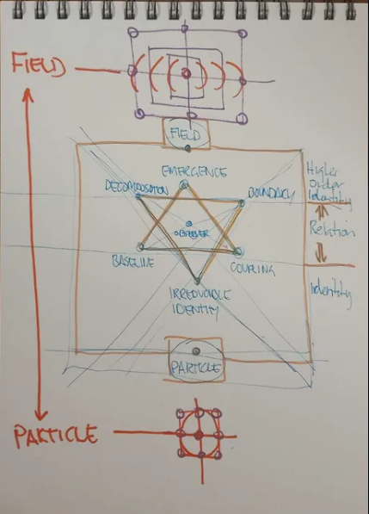
Figure A1. Original sketch: particle-to-field axis, reduction / emergence directions, and central relational geometry.

University Handover Note
This document is intended to support an initial academic conversation. It is deliberately detailed enough to show that the research has an internal architecture, but bounded enough to leave formal mechanisms, unpublished code, thresholds and protectable implementation details outside the initial disclosure. The recommended next action is to select one or two research questions from Chapter 11 and invite domain specialists to critique the definitions and experimental design before any claim of generality is made.
The strongest next step is not more conceptual expansion. It is formalisation, comparison, falsification and independent reproduction.

